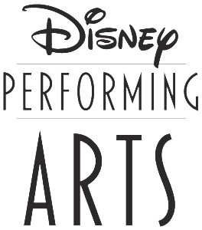

# CHORUS DISNEY TRIP

# **FRIDAY, NOVEMBER 9th, 2018 4:30 AM-11:30PM**

# FIFTH GRADE STUDENTS WILL PARTICIPATE IN THE **ACTING 101 WORKSHOP**

FOURTH GRADE STUDENTS WILL PARTICIPATE IN THE **DISNEY SINGS WORKSHOP**

* **COST FOR PARK TICKET TO MAGIC KINGDOM & WORKSHOP FEE: $114.00**
* **TRANSPORTATION FEE: $44.00**
* **WORKSHOP T-SHIRT FEE: $12.00**
* **ADULT PARK ENTRANCE FEE: $82.00**

* Please keep in mind that workshop space is limited and open only to those students participating. (Parents are not allowed to attend the workshop)

*Parents will be able to accompany their child on this fieldtrip however you must provide your own transportation.

*The bus will only be reserved for students and staff members.

*We will be accepting payments in full on the September 26th for the “Back to School Bash” general chorus meeting.

* (Applicable only to adults accompanying a child)- If you are a Disney passholder than you can use your existing tickets to get into the park***.***
* ***If you and your child are passholders your child is still required to pay the workshop/entrance fee.***